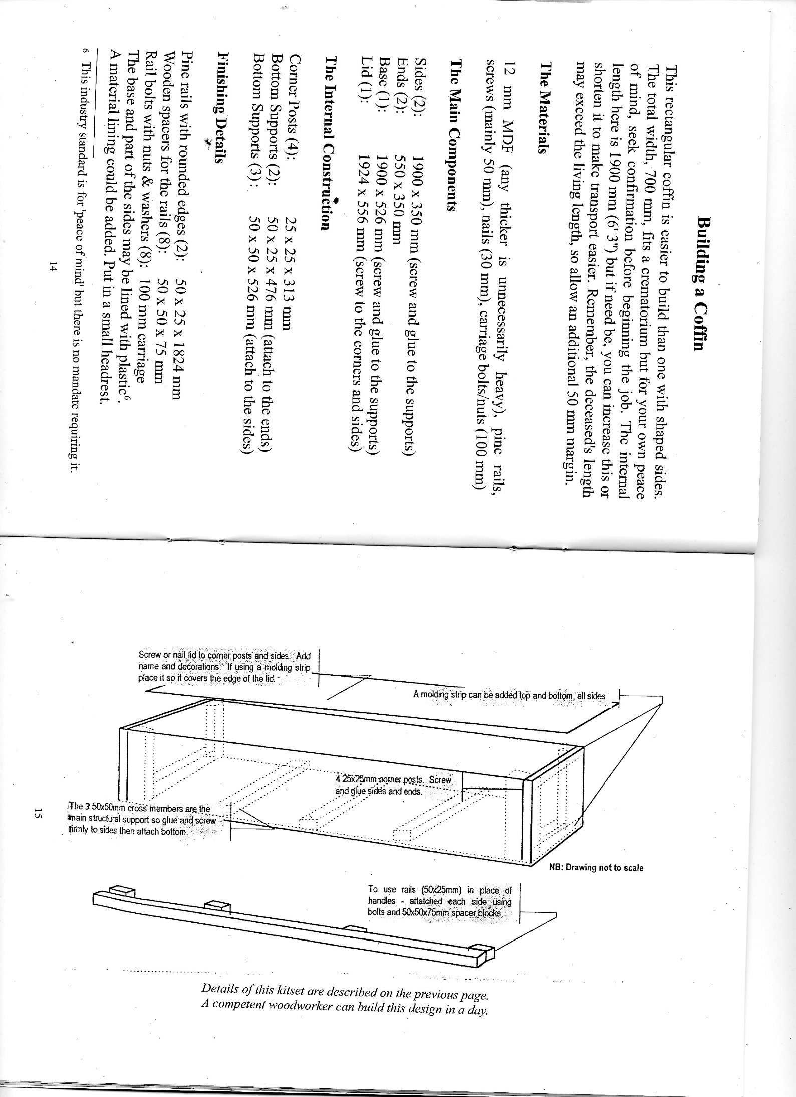

From Tomlinson, Philip Arranging a Funeral (3rd ed 2003)